|  |  |
| --- | --- |
| **Exp No: 6**  **Date: 07.04.25** | **HTTP SESSION** |

**AIM:**

To  Write a Servlet to demonstrate session tracking using HTTP Session.Implement a simple login system where the user's session is tracked.

**PROGRAM:**

**httpsessionhandle.java**

package com.sachin.servlet;  
  
import java.io.IOException;  
import java.io.PrintWriter;  
  
import javax.servlet.ServletException;  
import javax.servlet.annotation.WebServlet;  
import javax.servlet.http.HttpServlet;  
import javax.servlet.http.HttpServletRequest;  
import javax.servlet.http.HttpServletResponse;  
import javax.servlet.http.HttpSession;  
  
/**  
 * Servlet implementation class formsession  
 */  
@WebServlet("/formsession")  
public class formsession extends HttpServlet {  
private static final long serialVersionUID = 1L;  
         
    /**  
     * @see HttpServlet#HttpServlet()  
     */  
    public formsession() {  
        super();  
        // TODO Auto-generated constructor stub  
    }  
  
/**  
* @see HttpServlet#doGet(HttpServletRequest request, HttpServletResponse response)  
*/  
protected void doGet(HttpServletRequest request, HttpServletResponse response) throws ServletException, IOException {  
// TODO Auto-generated method stub  
response.getWriter().append("Served at: ").append(request.getContextPath());  
}  
  
/**  
* @see HttpServlet#doPost(HttpServletRequest request, HttpServletResponse response)  
*/  
@SuppressWarnings("deprecation")  
protected void doPost(HttpServletRequest request, HttpServletResponse response) throws ServletException, IOException {  
String username = "sachin";  
String password = "sac_1144";  
  
PrintWriter p = response.getWriter();  
String user = request.getParameter("username");  
String pass = request.getParameter("password");  
  
if(user.equals(username) && pass.equals(password))  
{  
HttpSession session = request.getSession(true);  
session.putValue("username", user);  
  
response.sendRedirect(request.getContextPath() + "/formsessiondisplay");  
}  
  
else  
{  
p.println("fail");  
}  
}  
  
}

**HttpSessionHandleDisply.java**

package com.sachin.servlet;  
  
import java.io.IOException;  
import java.io.PrintWriter;  
  
import javax.servlet.ServletException;  
import javax.servlet.annotation.WebServlet;  
import javax.servlet.http.HttpServlet;  
import javax.servlet.http.HttpServletRequest;  
import javax.servlet.http.HttpServletResponse;  
import javax.servlet.http.HttpSession;  
  
/**  
 * Servlet implementation class formsessiondisplay  
 */  
@WebServlet("/formsessiondisplay")  
public class formsessiondisplay extends HttpServlet {  
private static final long serialVersionUID = 1L;  
         
    /**  
     * @see HttpServlet#HttpServlet()  
     */  
    public formsessiondisplay() {  
        super();  
        // TODO Auto-generated constructor stub  
    }  
  
/**  
* @see HttpServlet#doGet(HttpServletRequest request, HttpServletResponse response)  
*/  
protected void doGet(HttpServletRequest request, HttpServletResponse response) throws ServletException, IOException {  
PrintWriter p = response.getWriter();  
HttpSession session = request.getSession(true);  
  
@SuppressWarnings("deprecation")  
String user_name = (String)session.getValue("username");  
p.println("Username is " + user_name);  
}  
  
/**  
* @see HttpServlet#doPost(HttpServletRequest request, HttpServletResponse response)  
*/  
protected void doPost(HttpServletRequest request, HttpServletResponse response) throws ServletException, IOException {  
// TODO Auto-generated method stub  
doGet(request, response);  
}  
  
}

INDEX.HTML

<!DOCTYPE html>  
<html>  
<head>  
<meta charset="ISO-8859-1">  
<title>Insert title here</title>  
</head>  
<body>  
<h3>FORM HANDLE BY HTTP SESSION</h3>  
<form action="/sachin-144/formsession" method="POST" style="margin-left: 50px">  
<label>Username:  </label><input type="text" name="username" placeholder="Enter username" required/><br><br>  
<label>Password:  </label><input type="password" name="password" placeholder="Enter password" required/><br><br>  
<input type="submit" value="Login" style="margin-left: 130px"/>  
</form>  
</body>  
</html>

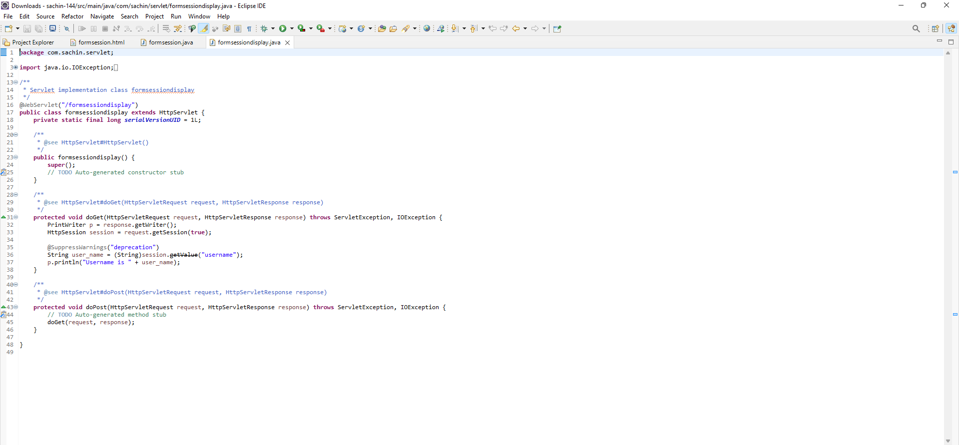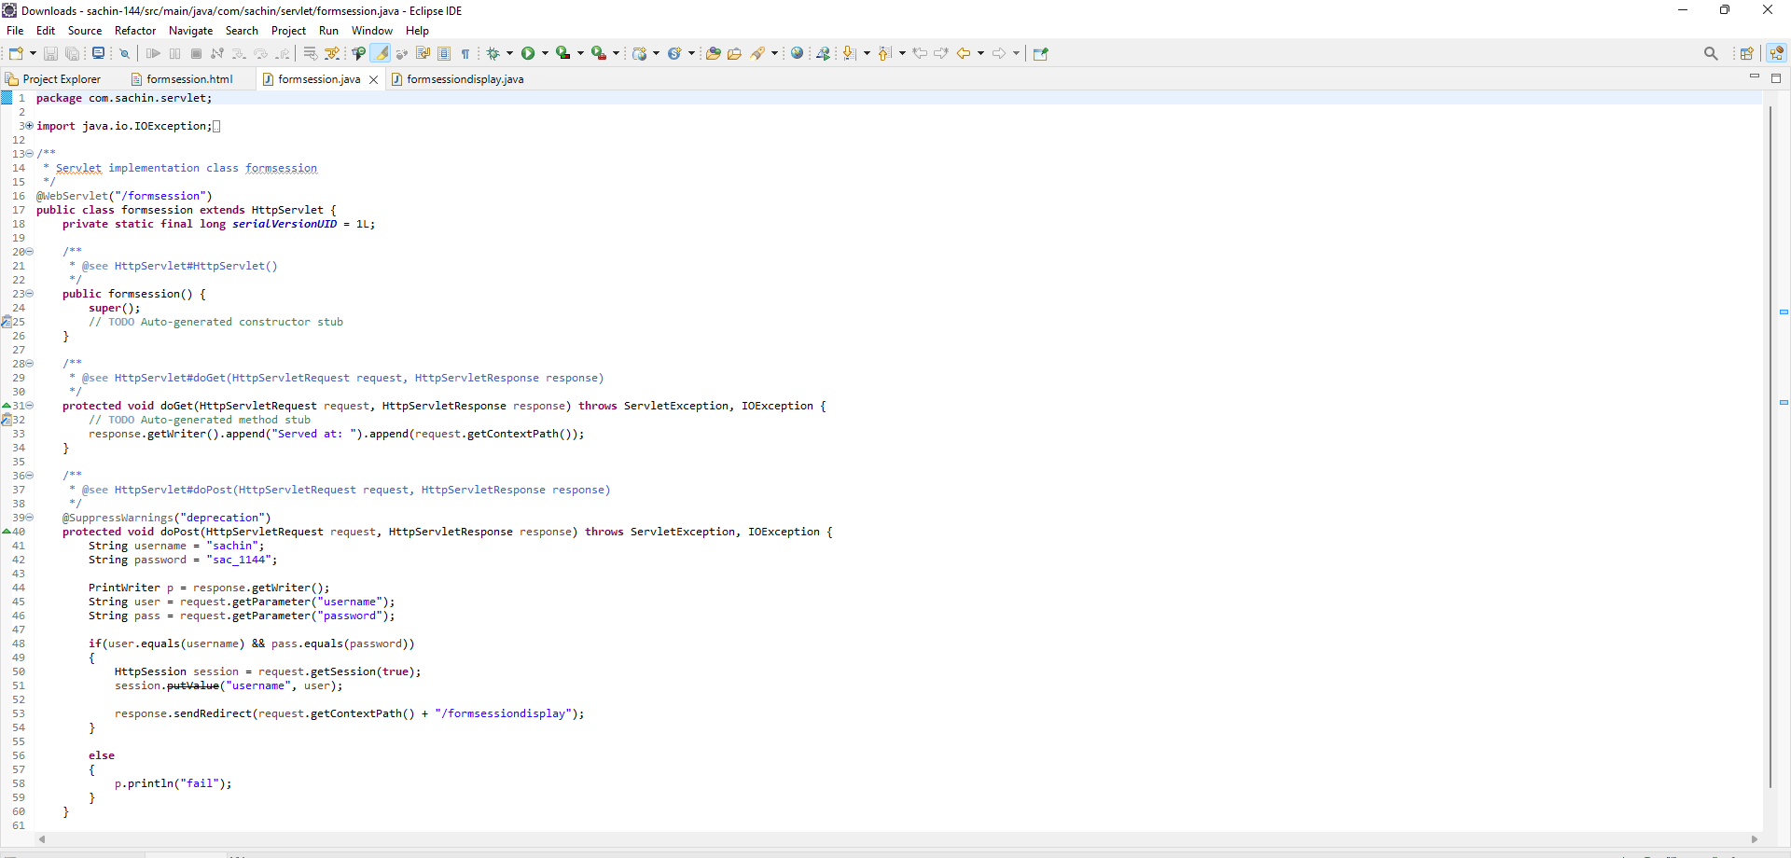

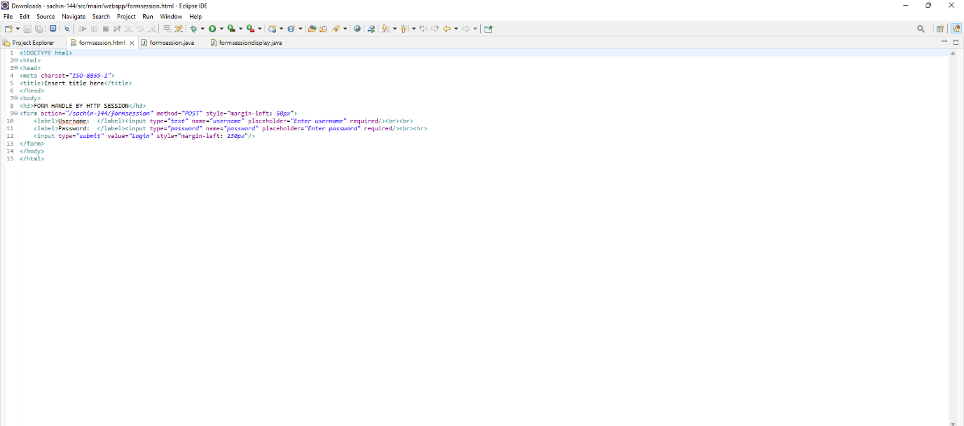

**OUTPUT:**

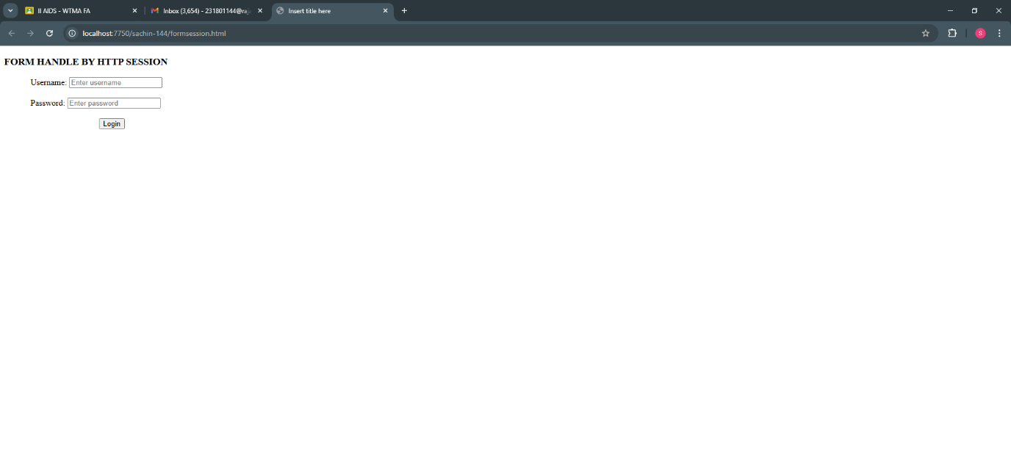

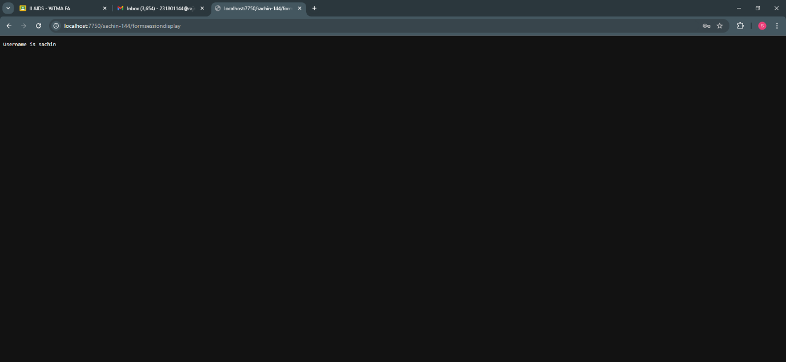

**RESULT :**Thus the To  Write a Servlet to demonstrate session tracking using HTTP Session.Implement a simple login system where the user's session is tracked. has been implemented and verified successfully